**CARWASH MANAGEMENT SYSTEM**

A project report on the need to computerise the data processing activities of A CAR WASH

Prepared by:

PURITY

REG NUMBER:

SCHOOL:

Submitted to:

Date:

# Title page

# Table of Contents

# DEDICATION

I dedicate this project to my most loving parents for their indulgence in my education and enabling me to be in school at all times and encouraging me throughout my education from Form one to Form four thereby may the almighty God continue protecting them and giving them life together with my whole family members not forgotten.

# 

# REPORT STRUCTURE:

The aim of the new system is to replace the old manual system of keeping information with a new computerised system which is faster and more efficient.

Data collection was administered through various ways such as administering questionnaires and conducting interviews. The members and staff were actively involved in collection of information.

During collection of data, I noticed that all operations done manually have a number of disadvantages that cannot be assumed. It was therefore concluded that the manual system was basically hectic and required a new system to cancel out major issues.

Some of the problems encountered include:

1. Loss of data
2. Improper input of data
3. Theft

The carwash therefore decided that a new system had to be developed.

# ACKNOWLEDGEMENT

I give my sincere gratitude to my friends and family members who have continually supported me in many ways in the developing of this project.

# 

# DECLARATION

I declare that this is my original work. I do certify that it has never been submitted to any other institution for assessment or any awareness.

**Name**: Purity

**Signature** ……………………………………………….

**Date** ……………………………………………….

Table of Contents

Title page ii

Table of Contents ii

DEDICATION iii

REPORT STRUCTURE: iv

ACKNOWLEDGEMENT v

DECLARATION vi

List of Figures 4

CHAPTER ONE: INTRODUCTION 5

CHAPTER TWO: SYSTEM ANALYSIS 6

2.1.0 Problem Definition. 6

2.2.0 OVERVIEW OF THE EXISTING SYSTEM 7

2.3.0 SYSTEM STRUCTURE OF THE OLD SYSTEM 7

2.4.0 PROBLEMS FACED BY THE CURRENT SYSTEM 7

2.5.0 INFORMATION GATHERING 7

2.6.0 About the proposed system 7

2.7.0 OBJECTIVES 8

2.8.0 BENEFITS EXPECTED 8

2.9.0 ADVANTAGES OF THE PROPOSED SYSTEM 8

3.0.0 DISADVANTAGES OF THE SYSTEM 9

3.0.1SCOPE OF THE STUDY 9

3.0.2 FEASIBILITY STUDY 9

3.0.2.1 OPERATIONAL FEASIBILITY 9

3.0.2.2 TECHNICAL FEASIBILITY 9

3.0.2.3 ECONOMIC FEASIBILITY 9

3.0.2.4 SCHEDULE FEASIBILITY 10

3.0.3 SYSTEM SPECIFICATION 10

3.0.3.1 Software requirements 10

3.0.3.2 Hardware requirements 10

3.0.3.3 User requirements 10

CHAPTER THREE: SYSTEM DESIGN 11

3.1 ENTITY RELETIONSHIP DIAGRAM 12

3.1Design 13

3.1.1 Table Design 13

14

3.1.2 Form design 16

3.1.3 Output Design 22

CHAPTER FOUR: SYSTEM IMPLEMENTATION 27

4.1.0 File Conversion 27

4.1.1 Staff Training 27

4.1.2 Changeover Strategies 27

4.1.3 Security Control Measures 27

4.2 USER MANUAL 28

4.2.1 INSTALLATION GUIDE AND REQUIREMENTS 28

4.2.2 INSTALLATION GUIDE 28

4.2.3 REQUIREMENTS 28

4.2.4 TROUBLESHOOTING 28

LOADING THE SYSTEM 29

MISCELLANEOUS 30

4.7 CONCLUSION 30

4.8 RECOMMENDATION 31

5.0 APPENDICES 31

5.1 APPENDIX II 31

Abbreviations 33

# List of Figures

Figure 1; Economic Feasibility 9

Figure 2; Schedule Feasibility 9

Figure 3; System flow chart 11

Figure 4; Entity Relationship diagram 11

Figure 5; Members table Design View 12

Figure 6; Staff Table Design View 12

Figure 7; Cars Table |Design View 13

Figure 8; Services Table Design View 13

Figure9; Users Table Design View. 14

Figure 10; Log in Form 15

Figure 11; Main menu Form Design 16

Figure 12 Members Form 17

Figure 13 Staff Form 18

Figure 14 Services Form 19

Figure 15 Cars Form 20

Figure 17; Members report 21

Figure 18; Staff report 21

Figure 19; Cars report 22

Figure 20; Financial report 23

Figure 21; Services report 24

Figure 22; User report 25

Figure 25; Error 01 27

Figure 26; Error 02 27

Figure 27 LOG IN SCREEN 28

Figure 28 HOMEPAGE SCREEN 29

# CHAPTER ONE: INTRODUCTION

Car Wash Management system is a system that is useful and essential in the running of a car wash. It has therefore decided that a new computerised system has to be developed and to be put to practise immediately. Initially, all the data processing activities had been done manually. They include:

Maintain

* Financial records
* Records of services issued
* Records of carwash members
* Record of carwash employees
* Compute carwash finances
* Generate appropriate reports

The Car Wash wishes to replace the manual registration system with a computerized system that would ease input, manipulation and output of stored data in their inventory.

# CHAPTER TWO: SYSTEM ANALYSIS

## 2.1.0 Problem Definition.

This Car wash uses the availability of modern system to make learning more efficient in the institution. The program strictly maintains an account for all the resources owned by the carwash. The program also captures:

1. All details of staff
2. Details of members
3. Car details
4. Requisition orders
5. Records of services offered
6. Records of carwash finance

Car wash members are registered in the system alongside their cars. After registration to the system a customer can then acquire services that are offered at the car wash.

The forms are filled by any staff who has an account in the Car Wash Management System. Users in the system can only be added by an admin that is whoever is in charge of the system.

## 2.2.0 OVERVIEW OF THE EXISTING SYSTEM

The current system is manual and dependent on the efficiency of the employees.

It is tiresome and demands more labour which in turn leads to losses and misuse of resources.

## 2.3.0 SYSTEM STRUCTURE OF THE OLD SYSTEM

The Car Wash Management System uses manual methods to enter data process and give out information. These include the use of a pen, a paper and a manual calculator not forgetting files to store administrative information.

## 2.4.0 PROBLEMS FACED BY THE CURRENT SYSTEM

1. Processing of staff and customers information is not done in time and efficiently.
2. Generation of reports takes time.
3. There are data entry errors.
4. Data insecurity from unauthorized users or theft.
5. There are high overall operating costs.

## 2.5.0 INFORMATION GATHERING

The problems were identified through:

* Reviewing documents.
* Conducting interviews.
* Administering Questionnaires.
* Observations.

Samples of the used means are illustrated later in this booklet like a sample Questionnaire and a sample Interview.

## 2.6.0 About the proposed system

The proposed system aims to correct all the limitations and problems experienced in the current manual system. The system is supposed to make data processing and record keeping in the system easy and fast hence faster, and more clear data for further manipulation.

## 2.7.0 OBJECTIVES

1. **General objective**

The main objective is to develop a computerized system that will aid a Car Wash to monitor and improve on their resource allocation and utilization and increase the effectiveness of the car wash in service delivery.

1. **Specific Objectives**

The new system will ensure efficient management by:

* Improving the organization’s resource Management.
* Improved resource allocation and monitoring by proper maintenance of records.
* Improved time management by faster and efficient processes
* Generating Reports which helps in decision making.

## 2.8.0 BENEFITS EXPECTED

The proposed system is expected to provide a lot of benefits to a car wash

some of which are;

1. Increased data confidentiality and integrity.
2. Faster generation of reports.
3. Processing of a large number of members transaction and store details at a time.
4. Storing of a large number of data types.
5. Faster calculation of finances.
6. Faster production of reports in time.

#### 

## 2.9.0 ADVANTAGES OF THE PROPOSED SYSTEM

1. Easier and faster keying and updating of data.
2. Reduced data insecurity.
3. Faster calculation of finances.
4. Reduced data errors in information produced and data entered in the computer.
5. Reduced operating costs as operations are computerized.
6. Increased literacy in people in the field of I.T

## 3.0.0 DISADVANTAGES OF THE SYSTEM

1. Requires computer literate users to make it effective.
2. High costs incurred in the initial setup of the system.
3. Requires a system analyst to constantly review the system working overtime.
4. The system is wholly dependent on the users input and any error made during data entry cannot be determined by the computer, hence data is processed as it is.

## 3.0.1SCOPE OF THE STUDY

The scope / boundaries of the proposed system to be studied, analyst, designed, Constructed and implement are confined to a citizen.

## 3.0.2 FEASIBILITY STUDY

### 3.0.2.1 OPERATIONAL FEASIBILITY

The staff positively accepted the new system. Most gave it their full support and cooperation even though it will take time for those who are computer illiterate to get used to it. Basically, the new system is expected to produce positive outcomes.

### 3.0.2.2 TECHNICAL FEASIBILITY

The recent research on the old system shows that the management needs to purchase new equipment for efficient working of the new system to be installed. System units, monitors and keyboards are needed.

### 3.0.2.3 ECONOMIC FEASIBILITY

For the system to run successfully, new equipment has to be purchased. The following table shows a summary of the expenses to be expected.

|  |  |
| --- | --- |
| Category | Cost |
| Electricity bills | Ksh.30000 |
| Initial cost | Ksh.40000 |
| Maintenance cost | Ksh.24000 |

Figure 1; Economic Feasibility

### 

### 3.0.2.4 SCHEDULE FEASIBILITY

|  |  |
| --- | --- |
| ACTIVITY | DURATION |
| System analysis | 5 WEEKS |
| System design | 5 WEEKS |
| System construction | 5 WEEKS |
| System testing and debugging | 5 WEEKS |
| System implementation | 4 WEEKS |

Figure 2; Schedule Feasibility

## 3.0.3 SYSTEM SPECIFICATION

### 3.0.3.1 Software requirements

The proposed system requires the following

1. Windows operating system.

### 3.0.3.2 Hardware requirements

The following are the hardware requirements

1. VGA Monitor
2. System unit with a Processor of at least 600 MHz
3. At least 1GB RAM space
4. Data input devices e.g. keyboards, mouse.
5. Data networking cables for networking.

##### 

### 3.0.3.3 User requirements

The proposed system is user friendly and does not require the users to undertake any special training at all. However, the users must go through the system documentation to be able to know how to use the system efficiently and know all there is to know about it.

# 

# CHAPTER THREE: SYSTEM DESIGN

3.0 System flowcharts

Start

Open start form

Log in

Self service

Exit database

Close database

Password

Is Password correct?

Open main menu

Add service?

Add car?

Add staff?

Add memcer?

Add User ?

Details

Details

Details

Details

Details

member

Staff

car

Service

users

N0

N0

N0

N0

N0

N0

N0

Yes

Yes

Yes

Yes

Yes

Yes

Yes

Yes

N0

###### 

Yes

Stop

Figure 3; System flow chart

## 3.1 ENTITY RELETIONSHIP DIAGRAM

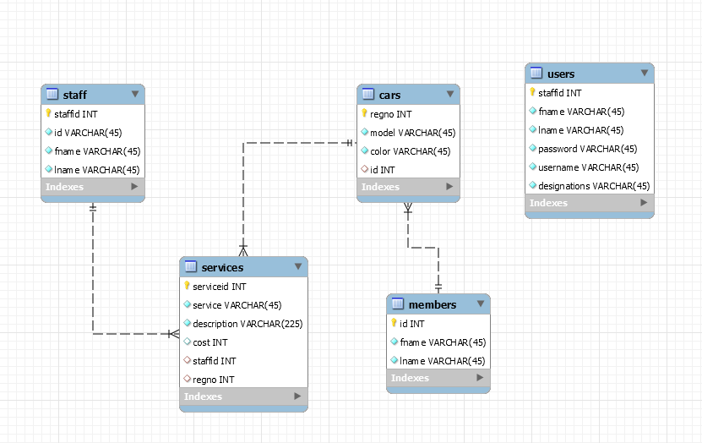

Figure 4; Entity Relationship diagram

## 3.1Design

### 3.1.1 Table Design

Figure 5; Members table Design View

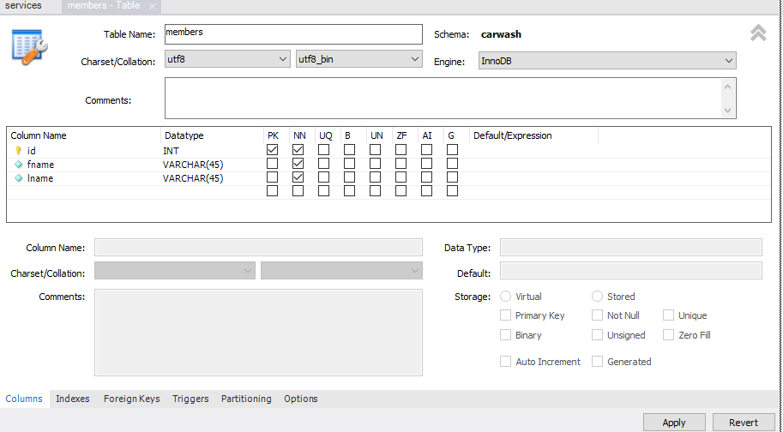

Figure 6; Staff Table Design View

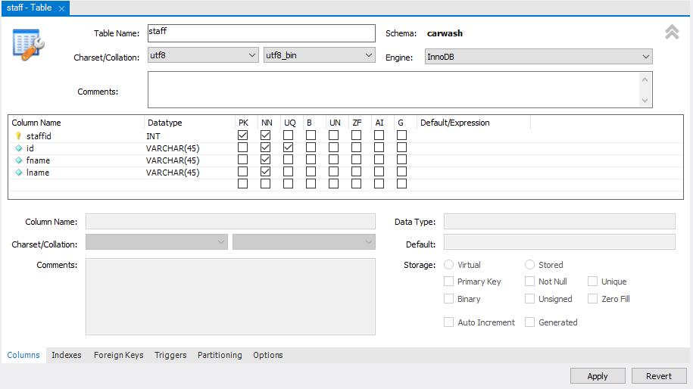

Figure 7; Cars Table |Design View

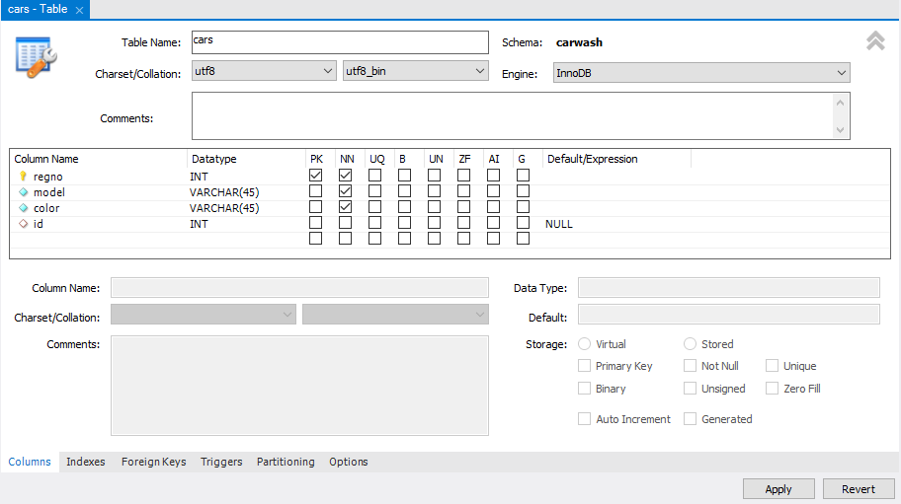

Figure 8; Services Table Design View

### 

Figure9; Users Table Design View.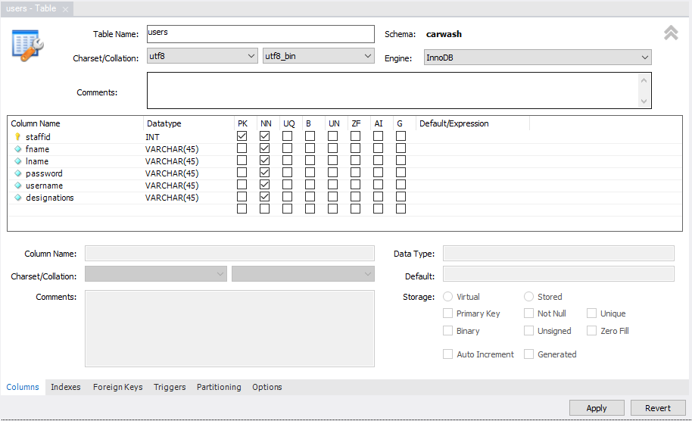

###### 

### 3.1.2 Form design

Figure 10; Log in Form

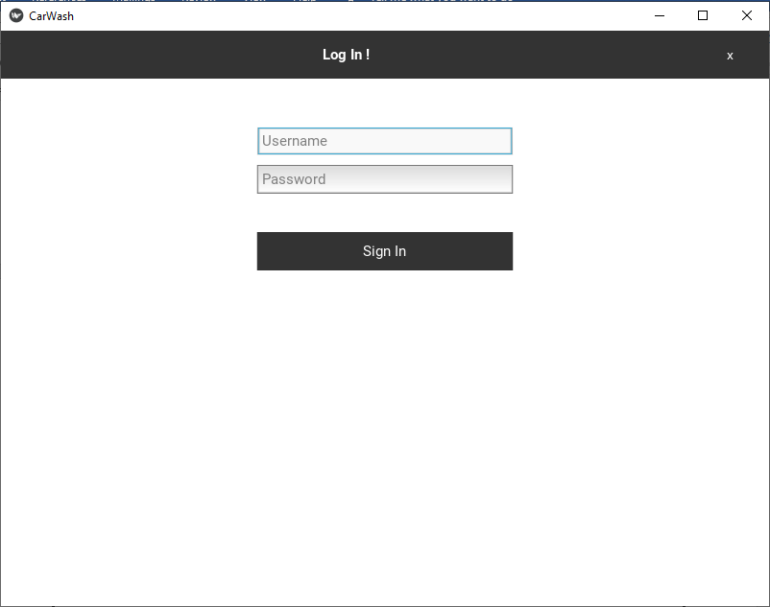

Figure 11; Main menu Form Design

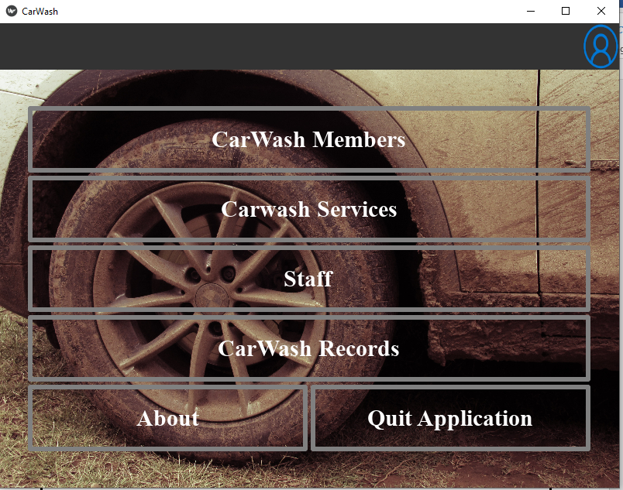

Figure 12 Members Form

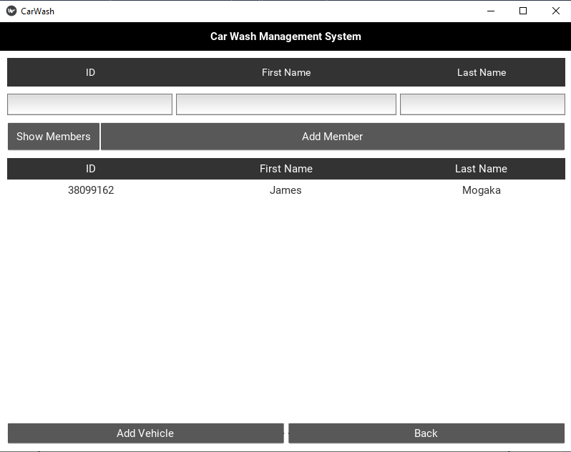

Figure 13 Staff Form

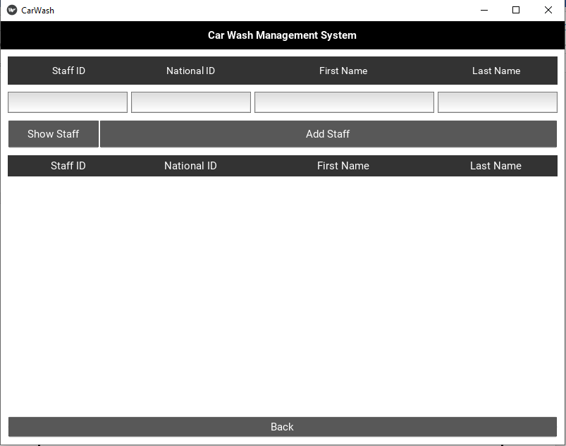

Figure 14 Services Form

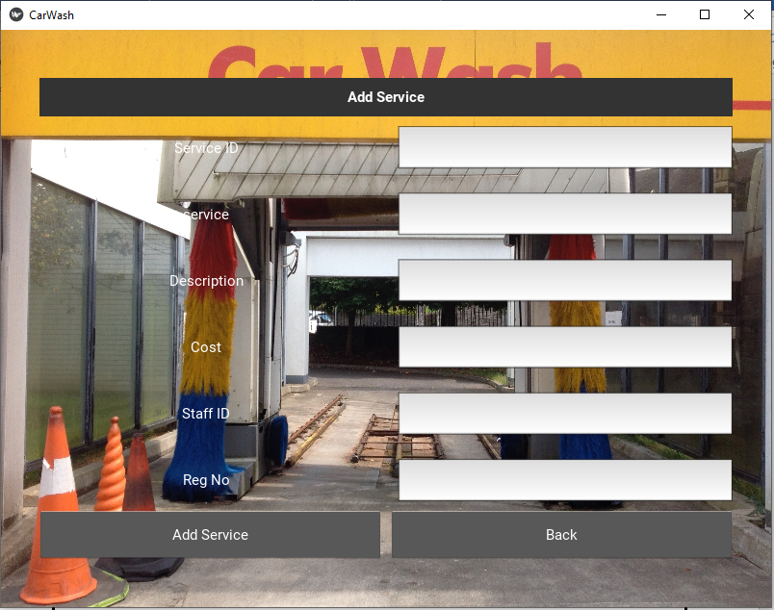

Figure 15 Cars Form

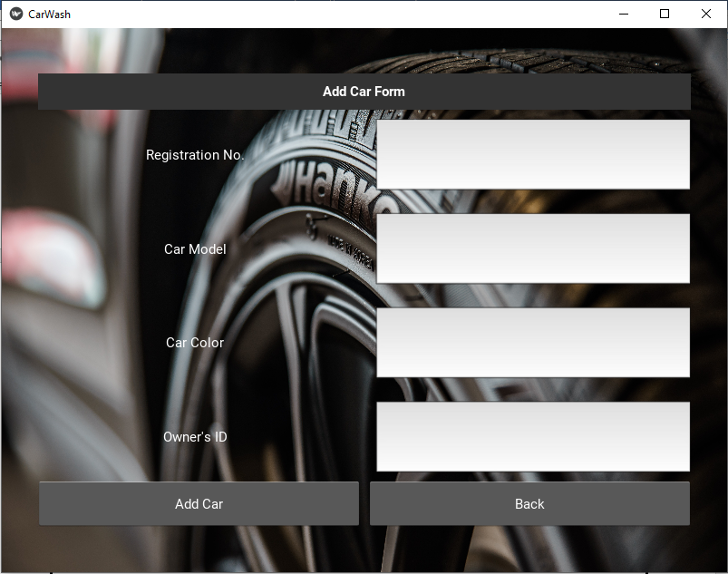

### 3.1.3 Output Design

Figure 17; Members report



Figure 18; Staff report

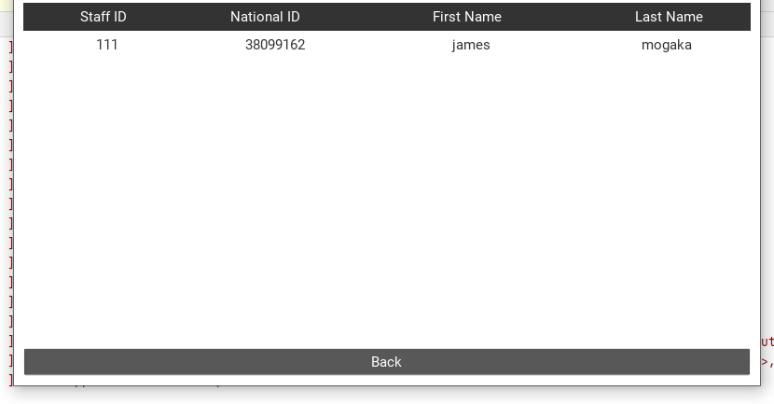

Lend id

Good serial

Quantity

Date of lending

Due date

Borrow report

Adm no

Employment id

F name

L name

Contacts

Department id

Teachers report

Figure 19; Cars report

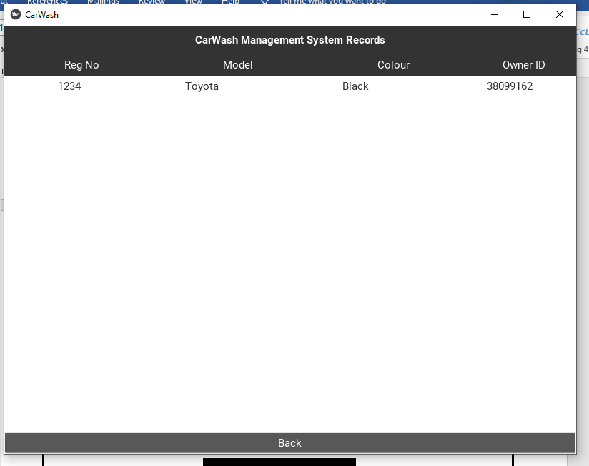

Figure 20; Financial report

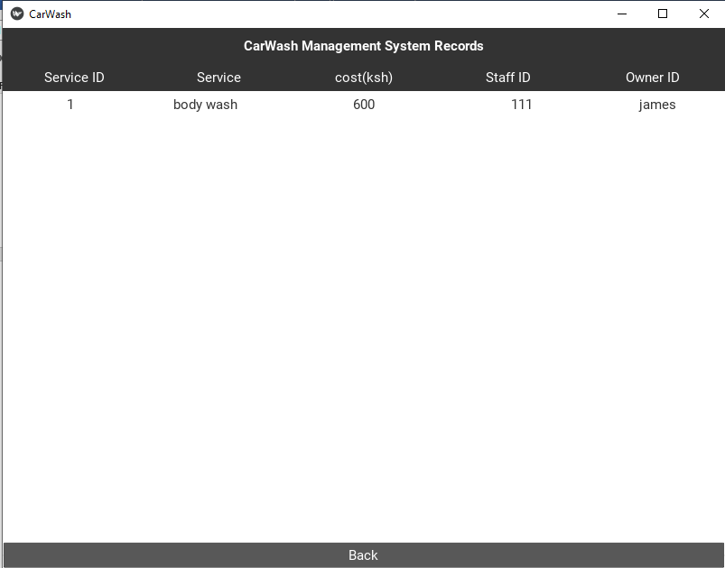

Figure 21; Services report

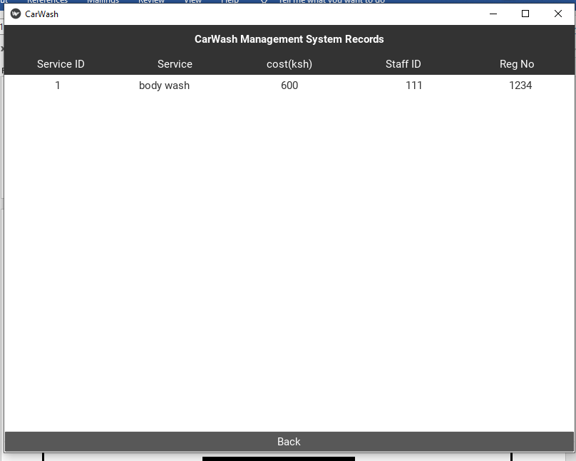

Figure 22; User report

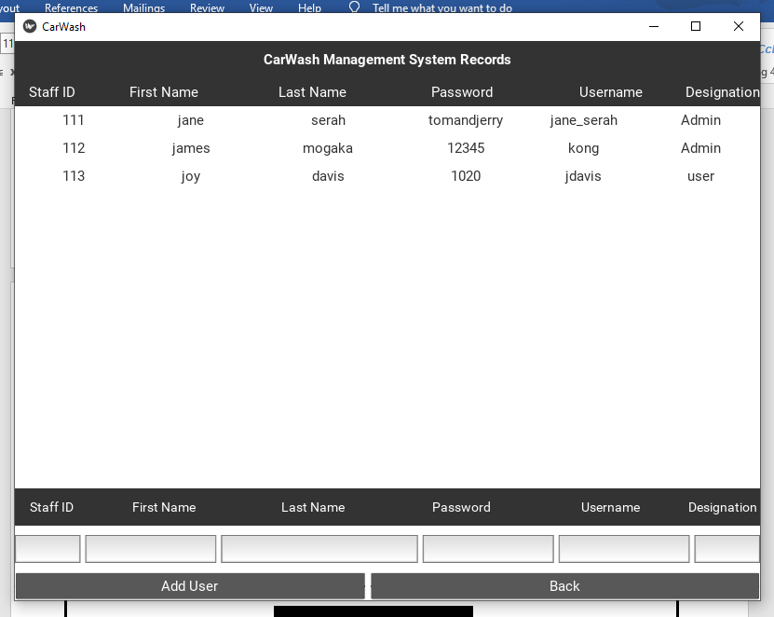

# CHAPTER FOUR: SYSTEM IMPLEMENTATION

## 4.1.0 File Conversion

The system runs on any windows based operating system.

### 4.1.1 Staff Training

The users need to have education up to at least form four and have studied computer within that time. A user manual is provided later in this booklet so as to avoid confusion while using this system.

### 4.1.2 Changeover Strategies

Changing from the old to new system depends on the opinion of the residents/ user. The changeover strategies can either be straight, phased or parallel.

### 4.1.3 Security Control Measures

The inbuilt security features of the system are going to be properly configured to those of the user computer.

## 4.2 USER MANUAL

### 4.2.1 INSTALLATION GUIDE AND REQUIREMENTS

### 4.2.2 INSTALLATION GUIDE

1. Insert the CD-ROM or Flash drive containing the system on your system drive. After the system has completed loading, right click on the systems icon and click on install.
2. Wait for a moment as the system installs then click on Finish that is displayed on the desktop.

### 4.2.3 REQUIREMENTS

Hardware requirements:

1. Monitor
2. Flash disk(5 GB) and a hard disk with a minimum storage capacity of 5GB for the purpose of storage
3. Printer

Software requirements:

1. Microsoft windows operating system
2. Antivirus

### 4.2.4 TROUBLESHOOTING

Figure 25; Error 01

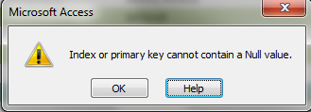

*Description*: You are trying to proceed to another record or field before entering the primary key.

*Solution*: Enter the key attribute of the record

Figure 26; Error 02

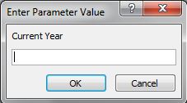

*Description:* You are trying to view records before entering the current year

*Solution:* Enter the current year

## LOADING THE SYSTEM

1. Click the start button, point to programs then click on the application icon. The start-up age appears below appears. You can either choose to log in provided you have the necessary details.
2. The Log in, the dialog box below appears



Figure 27 LOG IN SCREEN

3. Enter your password and click on the LOGIN button. The systems main menu appears as shown

Figure 28 HOMEPAGE SCREEN

## MISCELLANEOUS

### 4.7 CONCLUSION

Although the system has a high initial cost, it will contribute positively towards the development of the Car Wash. Its benefits will surpass the total costs incurred by a huge amount of money.

In addition, I have concluded the following:

1. If the new system is implemented it will promote literacy in people in terms of I.T
2. If the procedures are strictly followed with seriousness, then there shall be no complications experienced in terms of updating data
3. The system will ensure improved services offered by the system due to its speed of work.
4. It will contribute positively towards the corporate objectives when implemented in the future.

### 4.8 RECOMMENDATION

1. The need to have an Uninterruptible Power supply (UPS) is recommended for ensuring the stability of the power that is running from the mains to the computer hardware.
2. The use of recent computer software, which have some of the automated features required for running the new system.
3. The use of input devices that are accurate so that the new system can produce an output with reduced or no data entry errors.
4. The users of the system should be trained on how to use the new system.
5. There is need of purchasing new computer hardware and software to carry out the calculations automatically and faster.

## 5.0 APPENDICES

### 5.1 APPENDIX II

The table below shows the representations of the symbols used in the flowchart.

|  |  |
| --- | --- |
| Shape | Meaning |
|  | Start and Stop |
|  | Process |
|  | Arrow, used to indicate direction of flow |
|  | Connector: Used as a connecting point or interface for arrows coming from different directions |
|  | Decision: Used to specify a condition |
|  | Represents an input or an output |
|  | Off page connector, used to connect two or more pages. |

## Abbreviations

PK- Primary Key

RDMS- Relational Database Management System

UPS- Uninterruptable Power supply